### **Part 1: Addition and Subtraction**

**Pseudocode**:

1. Start
2. Prompt the user to input the first number (num1)
3. Prompt the user to input the second number (num2)
4. Convert user inputs to integers
5. Calculate the sum: sum_result = num1 + num2
6. Calculate the difference: diff_result = num1 - num2
7. Display the sum result to the user
8. Display the difference result to the user
9. End

**Source Code:**

# Part 1: Addition and Subtraction

# Asking the user for input

num1 = int(input("Enter the first number: "))

num2 = int(input("Enter the second number: "))

# Performing addition

sum_result = num1 + num2

print(f"The sum of {num1} and {num2} is: {sum_result}")

# Performing subtraction

diff_result = num1 - num2

print(f"The difference between {num1} and {num2} is: {diff_result}")

**Run:**

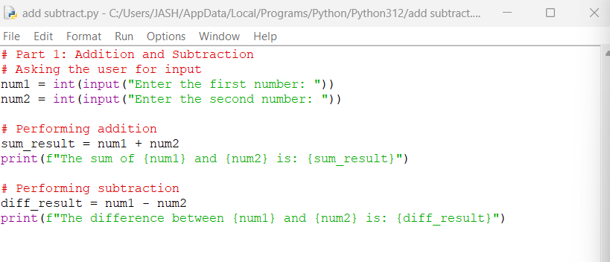

**Compile:**

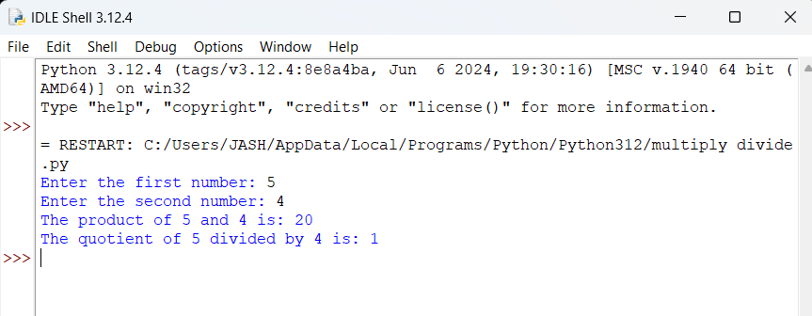

### **Part 2: Multiplication and Division**

**Pseudocode**:

1. Start
2. Prompt the user to input the first number (num1)
3. Prompt the user to input the second number (num2)
4. Convert user inputs to integers
5. Calculate the product: product_result = num1 * num2
6. Check if num2 is not zero to avoid division by zero
   * If num2 is not zero, calculate the quotient using integer division: quotient_result = num1 // num2
   * Display the quotient result to the user
   * If num2 is zero, display a message that division by zero is not allowed
7. Display the product result to the user
8. End

**Source Code:**

# Part 2: Multiplication and Division

# Asking the user for input

num1 = int(input("Enter the first number: "))

num2 = int(input("Enter the second number: "))

# Performing multiplication

product_result = num1 * num2

print(f"The product of {num1} and {num2} is: {product_result}")

# Performing division

# Checking for zero to avoid division by zero error

if num2 != 0:

quotient_result = num1 // num2 # Integer division

print(f"The quotient of {num1} divided by {num2} is: {quotient_result}")

else:

print("Division by zero is not allowed.")

**Run**

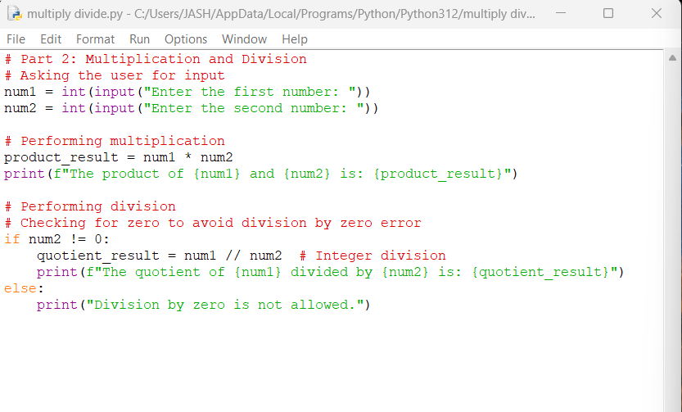

**Compile**

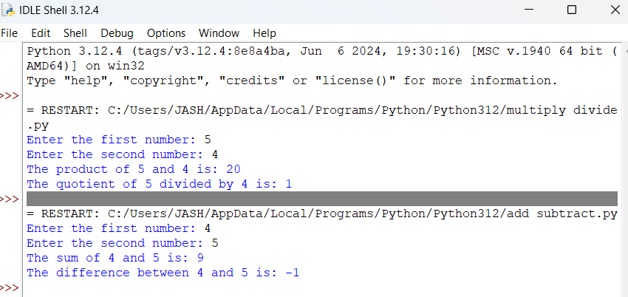

[**https://github.com/freezy39/fluffy-succotash/blob/main/Python%20Add_Sub_Mult_Div.docx**](https://github.com/freezy39/fluffy-succotash/blob/main/Python%20Add_Sub_Mult_Div.docx)

[**https://github.com/freezy39**](https://github.com/freezy39)